LED BLINKING IN SEQUENCE

LEARNING OBJECTIVES:-

* Writing code for Led so that it can blink in sequence
* Using Proteus software
* Using keil microvision software
* Creating Hex file
* Logic for Led Blinking in sequence

INPUTS:-

* Switch S1
* Switch S2
* Power
* Ports P0 – P7

OUTPUTS:-

* Pins are set to zero for getting the output

LOGIC:-

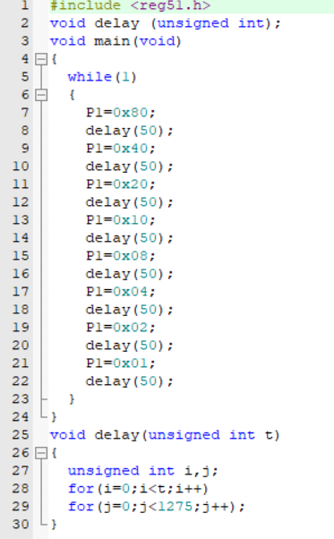

RESULT

1. **LED Sequence**:
   * The code controls a sequence of LEDs connected to Port 1 (P1) of an 8051 microcontroller.
   * It sequentially turns on individual LEDs one at a time, cycling through the following values: 0x01, 0x02, 0x04, 0x08, 0x10, 0x20, 0x40, and 0x80.
   * Each value corresponds to a different LED being illuminated.
2. **Delay Function**:
   * The delay(unsigned int t) function introduces a delay between LED transitions.
   * It waits for a total of t iterations, where each iteration consists of an inner loop running 1275 times.
   * The purpose of this delay is to control the timing between LED changes.